Assignment-2: Salesforce Trigger and controllers Assignment
Trigger Assignment
- How to create triggers? Explain with Example.
A trigger is Apex code that executes before or after specific DML events (insert, update, delete, undelete).

trigger AccountTrigger on Account (before insert, after insert) {
if(Trigger.isBefore && Trigger.isInsert){
System.debug('Before Insert Trigger fired');
}
if(Trigger.isAfter && Trigger.isInsert){
System.debug('After Insert Trigger fired');
}
}

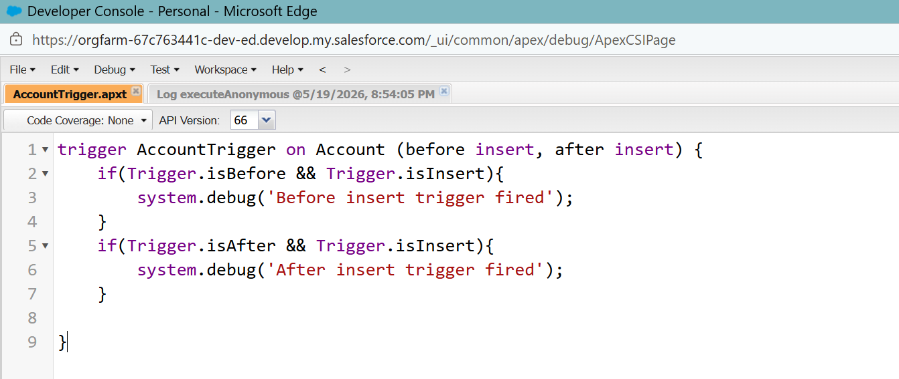

- Write a trigger example to insert contact when you create account.

trigger CreateContact on Account (after insert) {
List<Contact> c = new List<Contact>();
for(Account a : Trigger.new){
Contact nc = new Contact(FirstName = a.Name, LastName = 'Default', AccountId = a.Id);
c.add(nc);
}
if(!c.isEmpty()){
insert c;
}

}

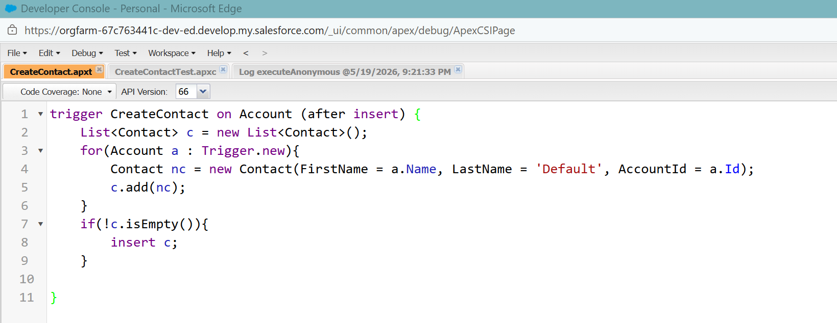

public class CreateContactTest {
public static void CreateContactTest(){
Account a = new Account(Name = 'Test Account');
insert a;

List<Contact> contacts = [SELECT Id, FirstName, LastName, AccountId
FROM Contact
WHERE AccountId = :a.Id];
system.debug('Contact inserted for:' + contacts);
}

}

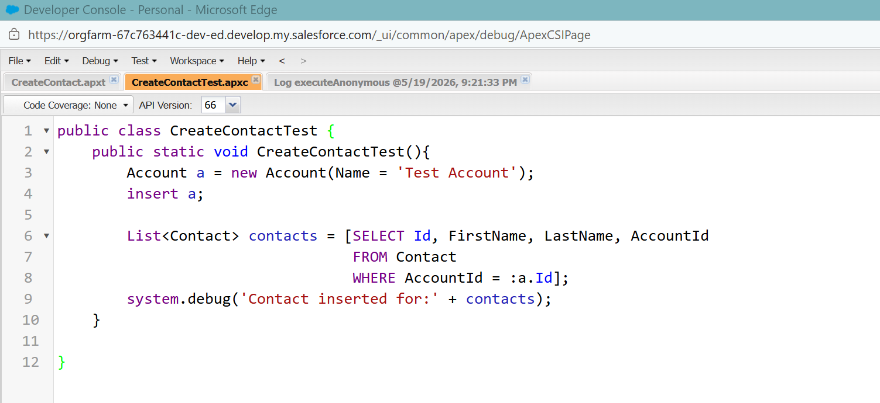

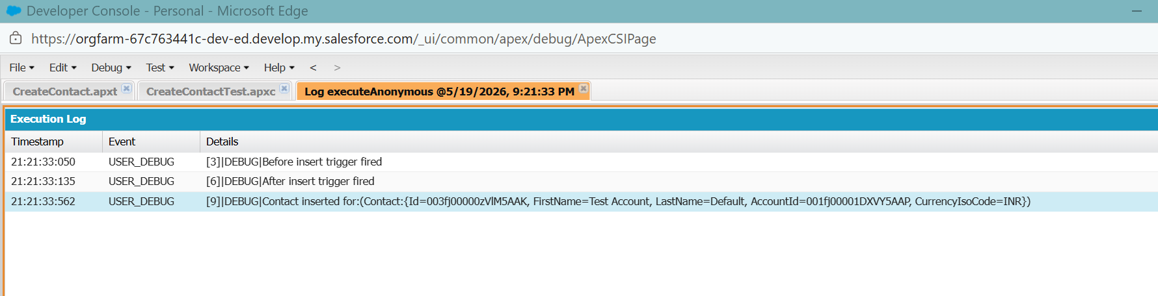

- Explain Trigger.oldmap with example.

Trigger.oldmap is a map of record IDs to the old versions of records before update/delete.

trigger oldMap on Account (before update) {
for(Account a : Trigger.new){
Account oldacc = Trigger.oldmap.get(a.Id);
if(a.Name != oldacc.Name){
system.debug('Account Name has been changed to' + a.Name);
}
}

}

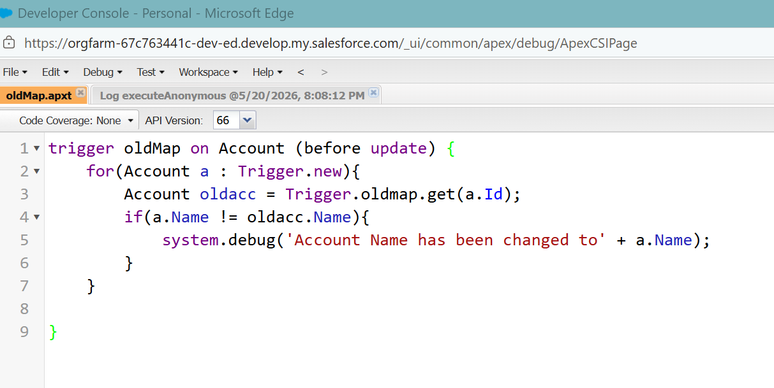

- Write an example to create list in Apex Trigger.

trigger EmailCollection on Contact (before insert) {
list<String> EmailList = new list<String>();
for(Contact c : Trigger.new){
EmailList.add(c.Email);
}
System.debug('List of Emails collected are :' + EmailList);

}

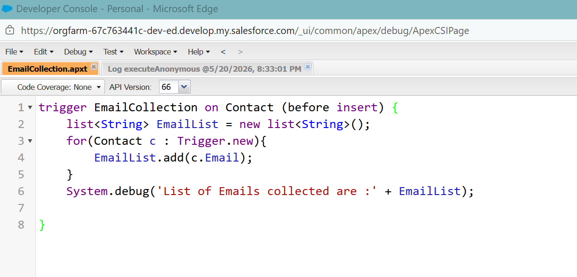

- Write an example to create Set & Map in Apex Trigger.

trigger SetMap on Account (before insert) {
Set<String> s = new Set<String>();
Map<Id,String> m = new Map<Id,String>();
for(Account a : Trigger.new){
s.add(a.Name);
m.put(a.Id, a.Name);
}
system.debug('Unique Account names are: ' + s);
system.debug('Account Map ' + m);

}

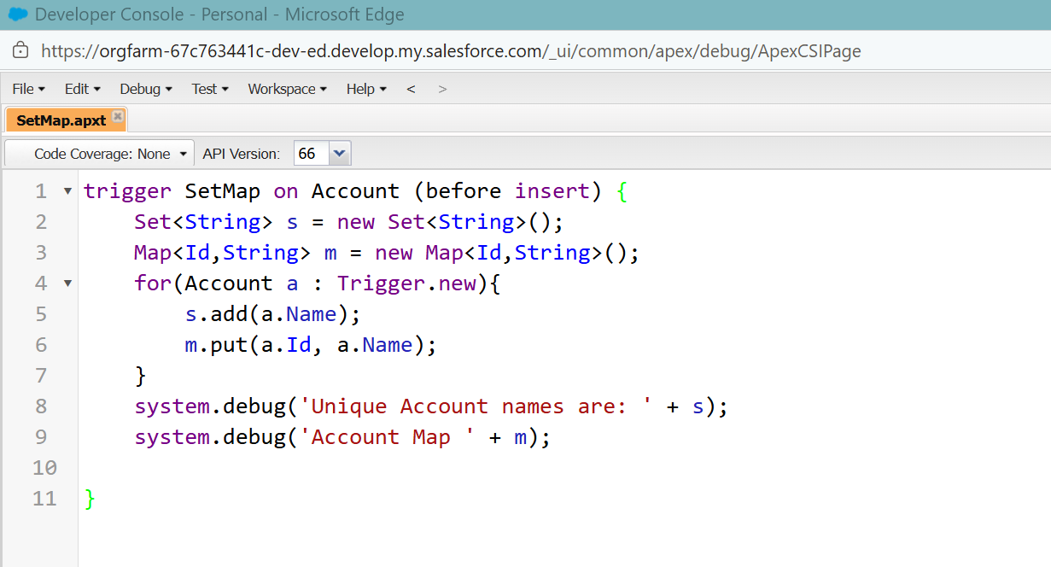

Controller Assignment

- Design VisualForce Page using Custom Controller Class.

public class MyAccountController {
public Account acc { get; set; }

public MyAccountController() {
Id accId = ApexPages.currentPage().getParameters().get('id');
acc = [SELECT Id, Name, Industry, Phone FROM Account WHERE Id = :accId];
}

public PageReference saveAccount() {
update acc;
return null;
}

}

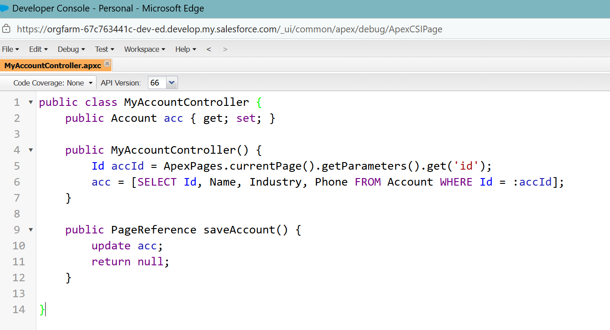

<apex:page controller="MyAccountController">
<apex:form>
<apex:pageBlock title="Edit Account">
<apex:pageBlockSection>
<apex:inputField value="{!acc.Name}" />
<apex:inputField value="{!acc.Industry}" />
<apex:inputField value="{!acc.Phone}" />
</apex:pageBlockSection>
<apex:commandButton value="Save" action="{!saveAccount}" />
</apex:pageBlock>
</apex:form>
</apex:page>

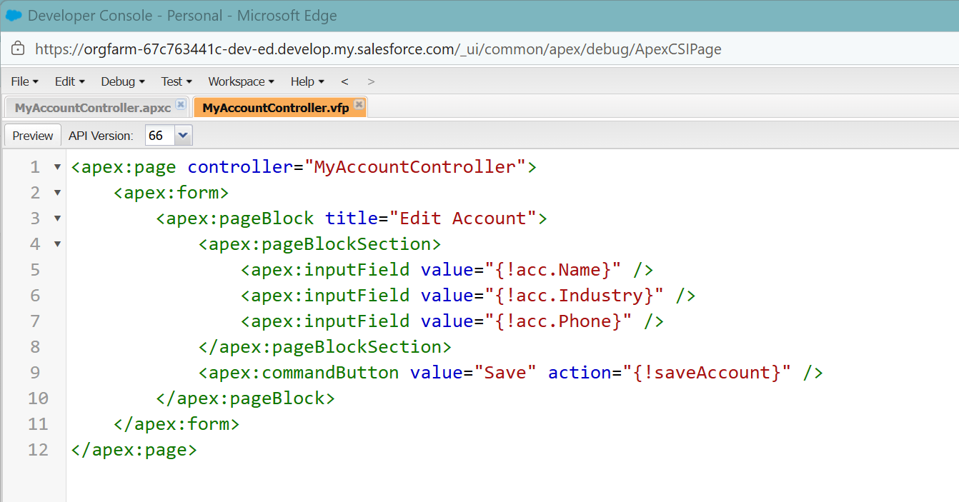

- Design VisualForce Page using Custom Controller Extensions Class.

public class AccountExtension {
public Account acc { get; set; }
public List<Contact> relatedContacts { get; set; }

public AccountExtension(ApexPages.StandardController stdController) {
this.acc = (Account)stdController.getRecord();
relatedContacts = [SELECT Id, Name, Email FROM Contact WHERE AccountId = :acc.Id];
}

public void updatePhone() {
acc.Phone = '9999999999';
update acc;
}

}

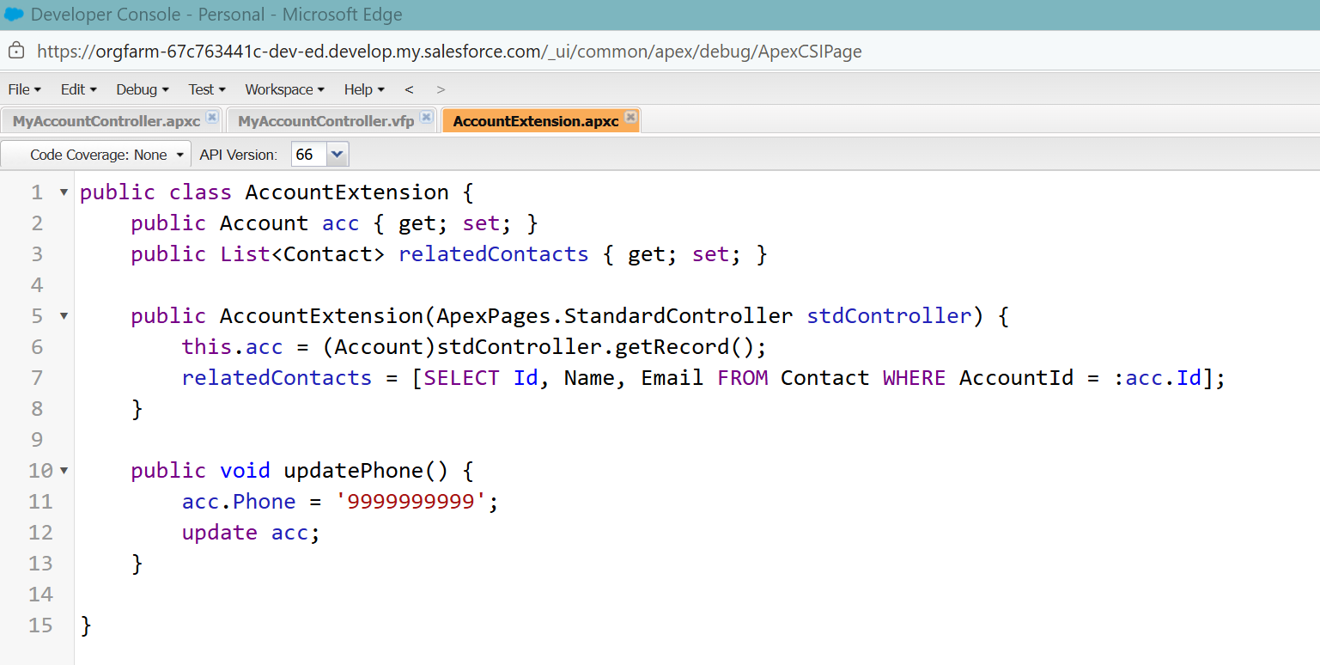

<apex:page standardController="Account" extensions="AccountExtension">
<apex:form>
<apex:pageBlock title="Account Details">
<apex:pageBlockSection>
<apex:inputField value="{!Account.Name}" />
<apex:inputField value="{!Account.Industry}" />
<apex:inputField value="{!Account.Phone}" />
</apex:pageBlockSection>
<apex:commandButton value="Save" action="{!save}" />
<apex:commandButton value="Update Phone" action="{!updatePhone}" />
</apex:pageBlock>

<apex:pageBlock title="Related Contacts">
<apex:pageBlockTable value="{!relatedContacts}" var="c">
<apex:column value="{!c.Name}" />
<apex:column value="{!c.Email}" />
</apex:pageBlockTable>
</apex:pageBlock>
</apex:form>
</apex:page>

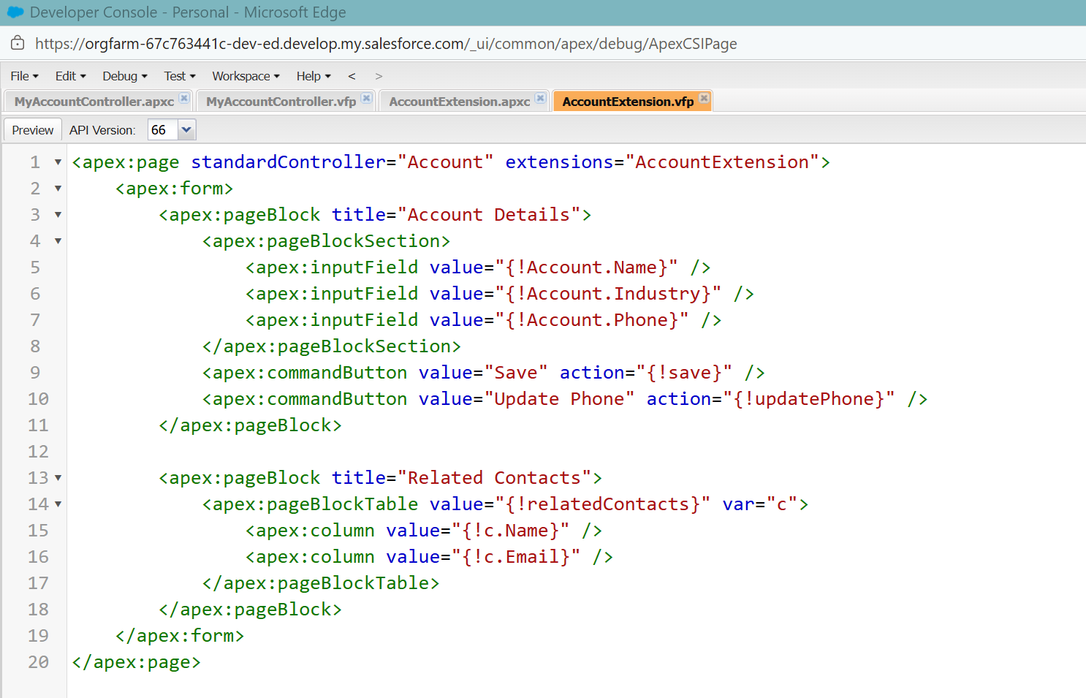
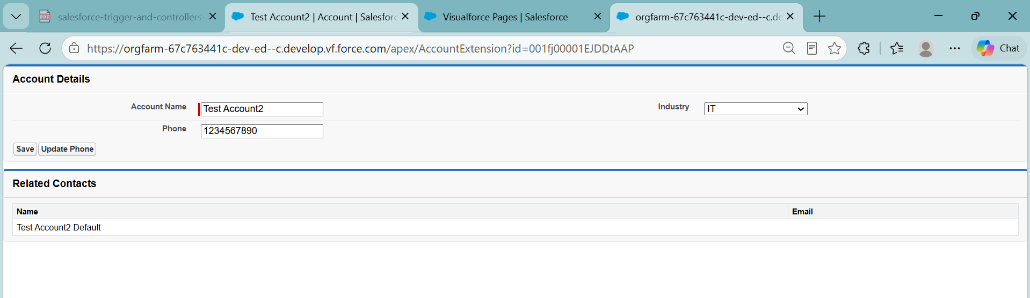
After update
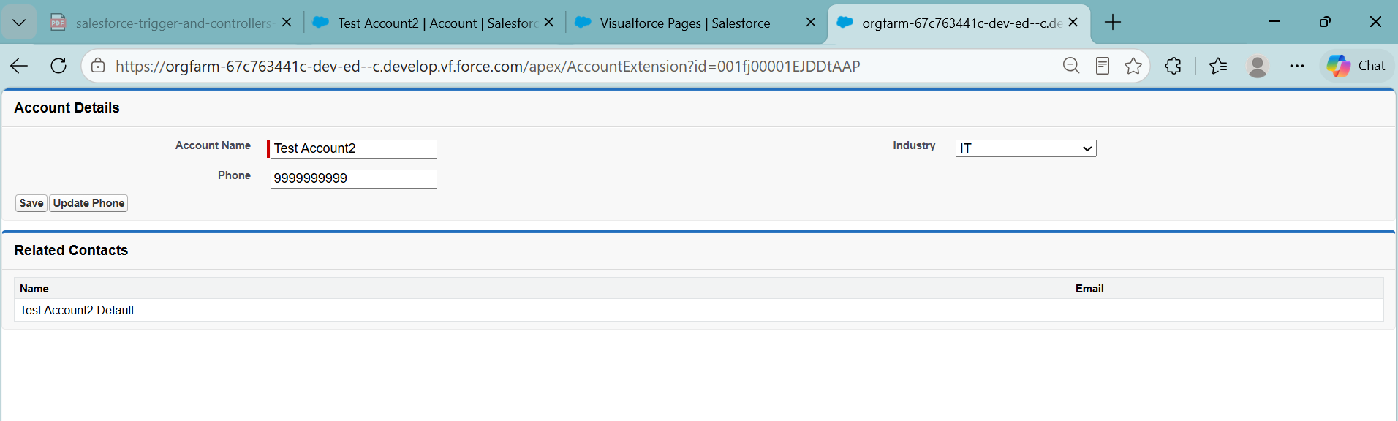

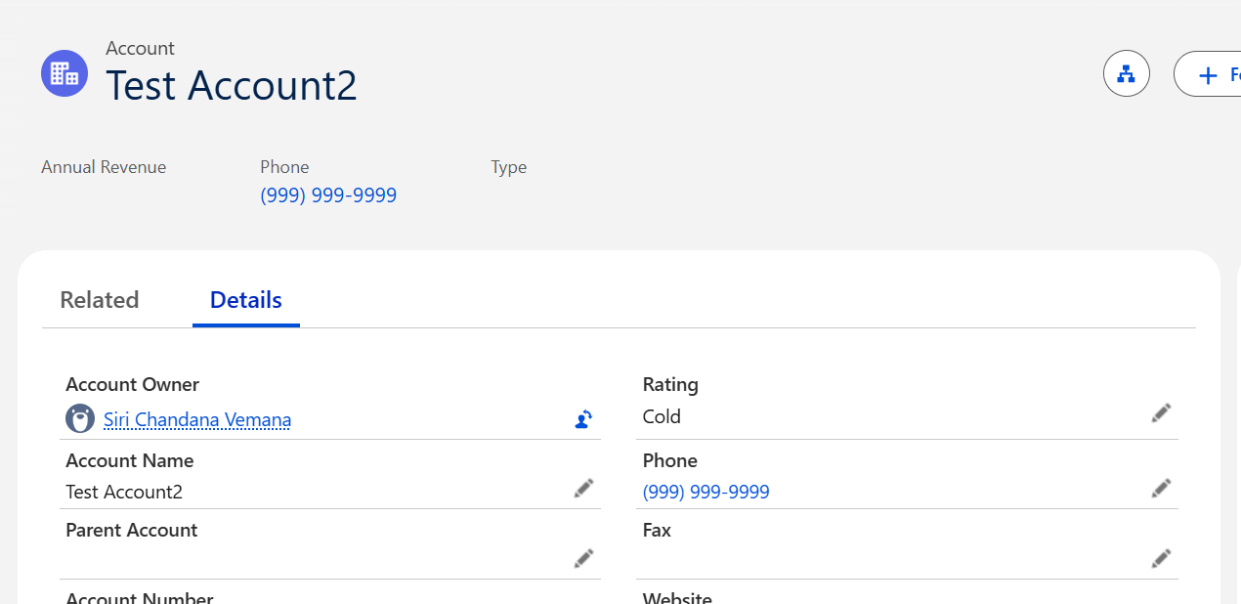

- Write an example to create new records using custom controller.

public class AccountCreationController {
public Account newAccount { get; set; }

public AccountCreationController() {
newAccount = new Account();
}

public PageReference saveAccount() {
try {
insert newAccount;
ApexPages.addMessage(new ApexPages.Message(ApexPages.Severity.CONFIRM,
'Account created successfully!'));

return new PageReference('/' + newAccount.Id);
} catch (Exception e) {
ApexPages.addMessage(new ApexPages.Message(ApexPages.Severity.ERROR,
'Error: ' + e.getMessage()));
return null;
}
}

}

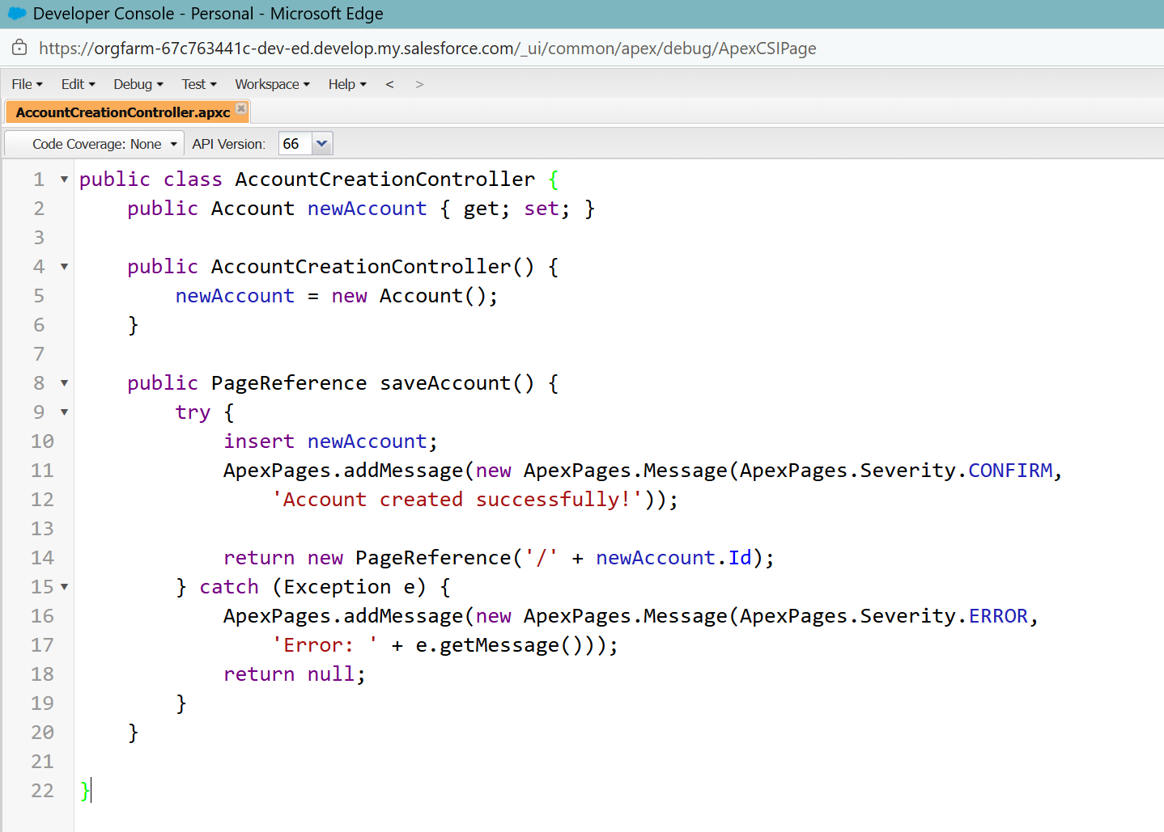

<apex:page controller="AccountCreationController">
<apex:form>

<apex:pageBlock title="Create New Account">
<apex:pageBlockSection columns="2">
<apex:inputField value="{!newAccount.Name}" />
<apex:inputField value="{!newAccount.Phone}" />
<apex:inputField value="{!newAccount.Industry}" />
</apex:pageBlockSection>

<apex:pageBlockButtons>
<apex:commandButton value="Save" action="{!saveAccount}" />
</apex:pageBlockButtons>
</apex:pageBlock>
</apex:form>
</apex:page>

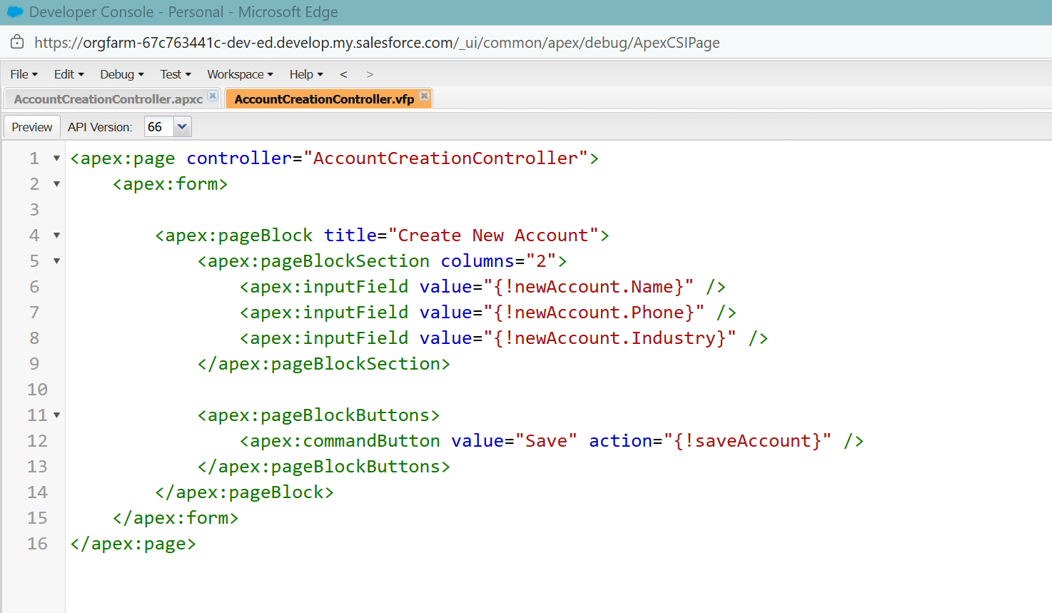

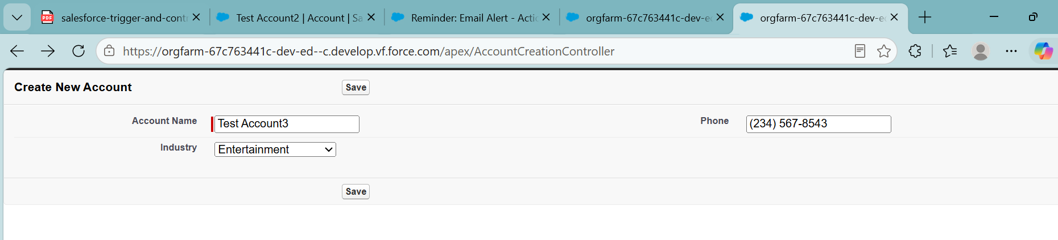

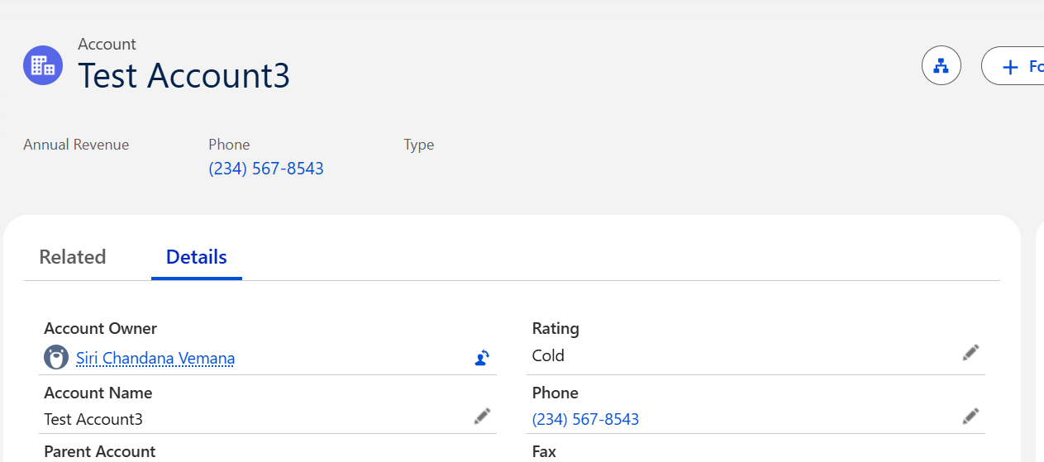

- Write an example to manage list of records by using standard controller.

Apex Class: AccountListController

public class AccountListController {

// Checkbox selection map
public Map<Id, Boolean> selectedIds {get; set;}

// Standard Set Controller
private ApexPages.StandardSetController stdController;

// Constructor
public AccountListController(ApexPages.StandardSetController controller) {

stdController = controller;

selectedIds = new Map<Id, Boolean>();

// Initialize map values
for(Account acc : (List<Account>)stdController.getRecords()) {

selectedIds.put(acc.Id, false);
}
}

// Update selected Accounts
public PageReference updateSelected() {

List<Account> updateList = new List<Account>();

for(Account acc : (List<Account>)stdController.getRecords()) {

if(selectedIds.get(acc.Id) == true) {

acc.Type = 'Customer - Direct';

updateList.add(acc);
}
}

if(!updateList.isEmpty()) {

update updateList;

ApexPages.addMessage(
new ApexPages.Message(
ApexPages.Severity.CONFIRM,
'Selected Accounts Updated Successfully'
)
);
}

return null;
}

// Delete selected Accounts
public PageReference deleteSelected() {

List<Account> deleteList = new List<Account>();

for(Account acc : (List<Account>)stdController.getRecords()) {

if(selectedIds.get(acc.Id) == true) {

deleteList.add(acc);
}
}

if(!deleteList.isEmpty()) {

delete deleteList;

ApexPages.addMessage(
new ApexPages.Message(
ApexPages.Severity.CONFIRM,
'Selected Accounts Deleted Successfully'
)
);
}

return null;
}
}
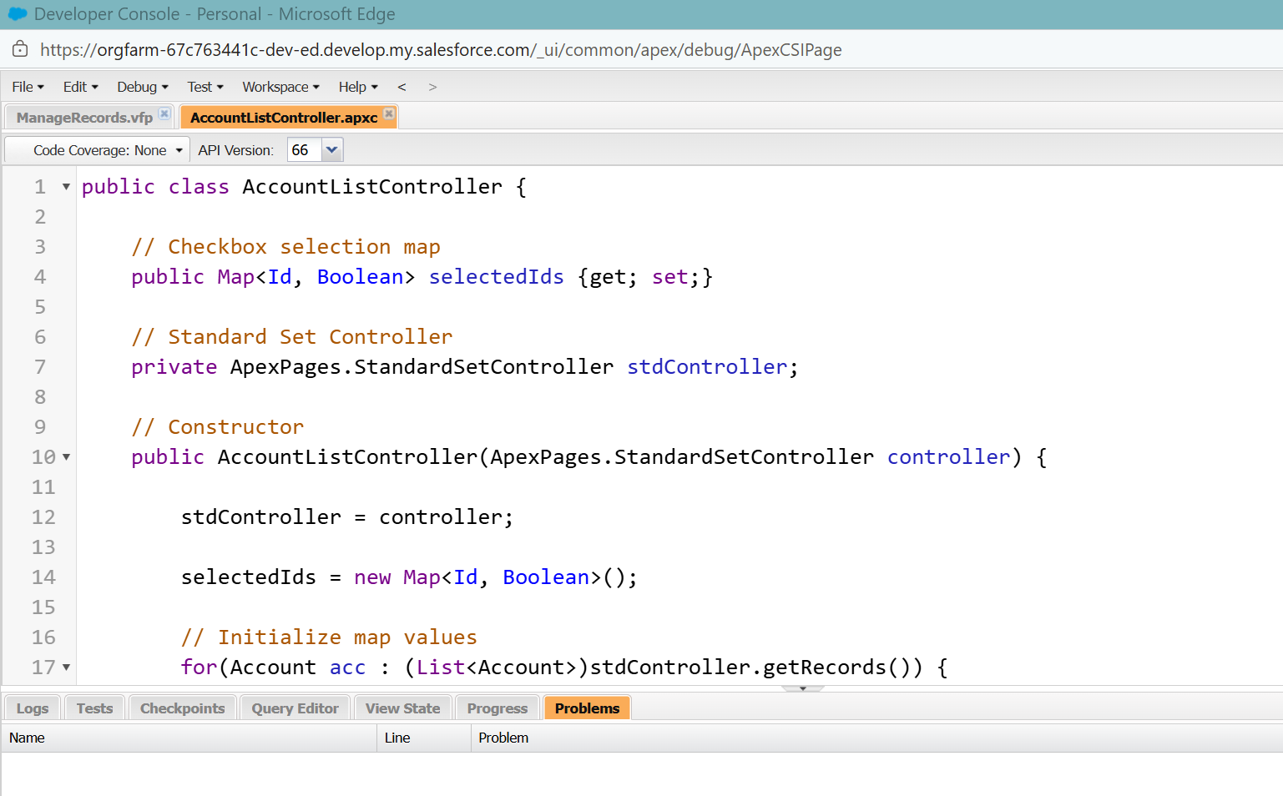

Visualforce Code:

<apex:page standardController="Account"
recordSetVar="accounts"
extensions="AccountListController">

<apex:form >

<apex:pageMessages />

<apex:pageBlock title="Manage Account Records">

<!-- Buttons -->
<apex:pageBlockButtons >

<apex:commandButton value="Previous"
action="{!previous}" />

<apex:commandButton value="Next"
action="{!next}" />

<apex:commandButton value="Update"
action="{!updateSelected}" />

<apex:commandButton value="Delete"
action="{!deleteSelected}" />

</apex:pageBlockButtons>

<!-- Account Table -->
<apex:pageBlockTable value="{!accounts}" var="acc">

<!-- Checkbox -->
<apex:column >
<apex:inputCheckbox value="{!selectedIds[acc.Id]}" />
</apex:column>

<!-- Fields -->
<apex:column value="{!acc.Name}" />
<apex:column value="{!acc.Type}" />
<apex:column value="{!acc.Phone}" />
<apex:column value="{!acc.Industry}" />

</apex:pageBlockTable>

</apex:pageBlock>

</apex:form>

</apex:page>

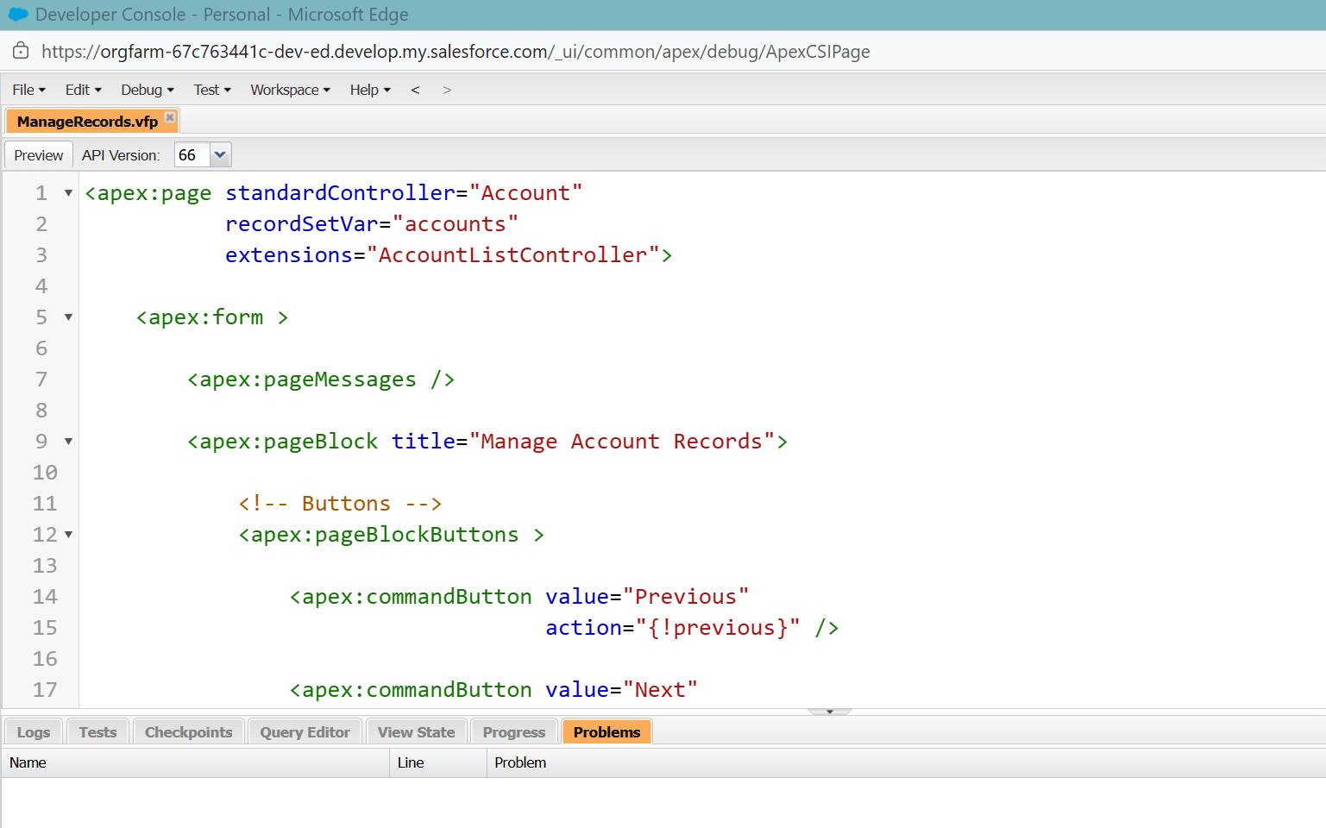

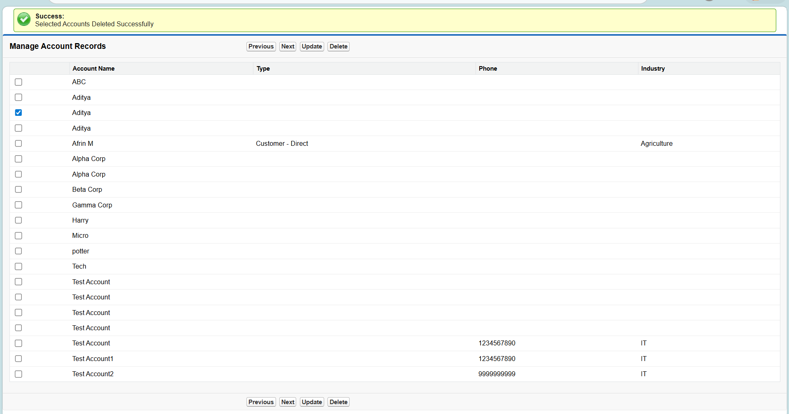

- Explain Rendered Function with example.

Apex Class: AccountRenderController

public class AccountRenderController {
public Account acc {get; set;}
public String discount {get; set;}

public AccountRenderController() {

acc = new Account(
Name = 'ABC Technologies',
Type = 'Customer - Direct'
);

discount = '10%';
}
public Boolean getShowDiscount() {
return acc.Type == 'Customer - Direct';
}
}

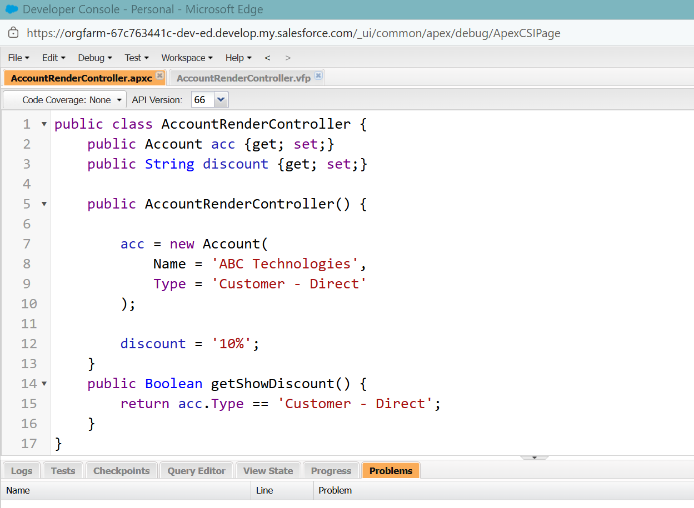

Visualforce Page: AccountRenderController

<apex:page controller="AccountRenderController">

<apex:form>

<apex:pageBlock title="Account Information">

<apex:pageBlockSection>

<!-- Account Name -->
<apex:outputText value="{!acc.Name}"/>

<!-- Account Type -->
<apex:outputText value="{!acc.Type}"/>

<!-- Discount Section -->
<apex:outputPanel rendered="{!showDiscount}">

<apex:outputLabel value="Special Discount"/>

<apex:inputText value="{!discount}"/>

</apex:outputPanel>

</apex:pageBlockSection>

</apex:pageBlock>

</apex:form>

</apex:page>

